AURA
Illustrated UI/UX Documentation
How the app should look and function — with visual mockups
MVP Scope: Mail · Calendar · Time · iOS
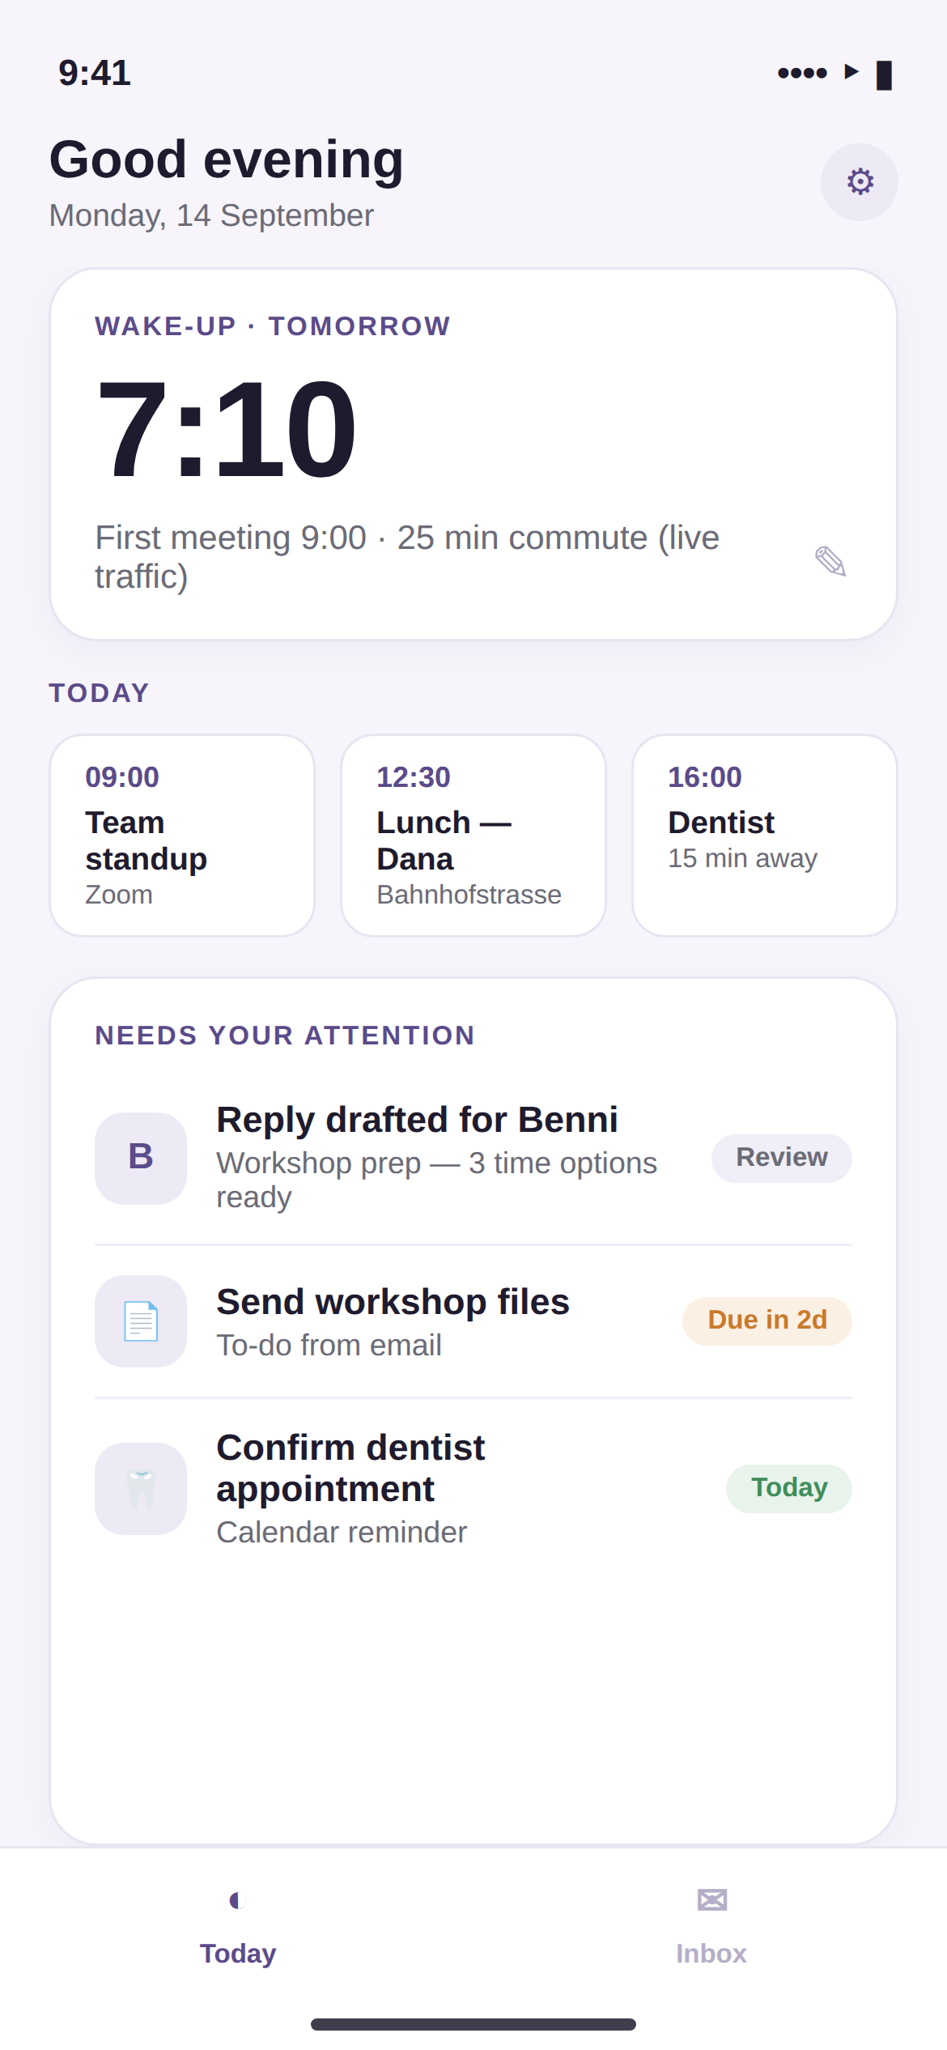
Version 1.0 · September 2026

Table of Contents
- 1. How to Use This Document
- 2. Design Language at a Glance
- 3. The App Shell
- 4. Onboarding Flow (illustrated)
- 4.1 Welcome
- 4.2 Connect Mail
- 4.3 First Value
- 5. The Today Screen (illustrated)
- 6. Inbox — Message List (illustrated)
- 7. Inbox — Reply Drafting (illustrated)
- 8. Settings (illustrated)
- 9. Lock Screen Widget (illustrated)
- 10. Full Journey Map: A Day With Aura
- 11. Interaction Rules Recap
- 12. Handoff Notes for Design & Engineering

1. How to Use This Document
This document illustrates every core screen of the Aura MVP (Mail, Calendar, and Time modules) with high-fidelity mockups, alongside the exact functional behavior behind each screen. It is meant to sit next to the Aura UI/UX & Build Documentation: that document defines the design tokens and technical implementation in detail; this one shows what the tokens actually look like once assembled into real screens, so nothing is left to interpretation between design and engineering.
Mockups are shown at iPhone screen proportions (390 × 844 pt, the iPhone 14/15 logical size) and use the color and type system defined in the design tokens: Aura Violet (#5B4B8A) as the single accent color, soft off-white surfaces, and no imagery or gamified elements — consistent with the calm, competent, discreet brand personality.

2. Design Language at a Glance
- One accent color (violet) used sparingly — for the active tab, primary buttons, and the left border of any AI-generated content.
- AI-generated content always lives in a distinct tinted card labelled "Aura suggests" — visible in nearly every screen — so the user always knows what Aura wrote versus what a human wrote.
- Numbers are the hero: the wake-up time, due-date badges, and time-slot chips are the most visually prominent elements on any screen, because precise, confident numbers are Aura's core value proposition.
- Cards over lists: related information is grouped into soft, bordered cards (20pt radius) rather than dense flat lists, reinforcing the "calm assistant" feel over a "busy dashboard" feel.

3. The App Shell
The MVP uses a simple two-tab bottom bar: Today and Inbox. A settings gear sits in the top-right corner of both tabs. There is no side navigation rail in the MVP — that returns in a later version once Banking, Parking, and Clothing modules justify the extra structure described in the full product documentation.

4. Onboarding Flow (illustrated)

4.1 Welcome
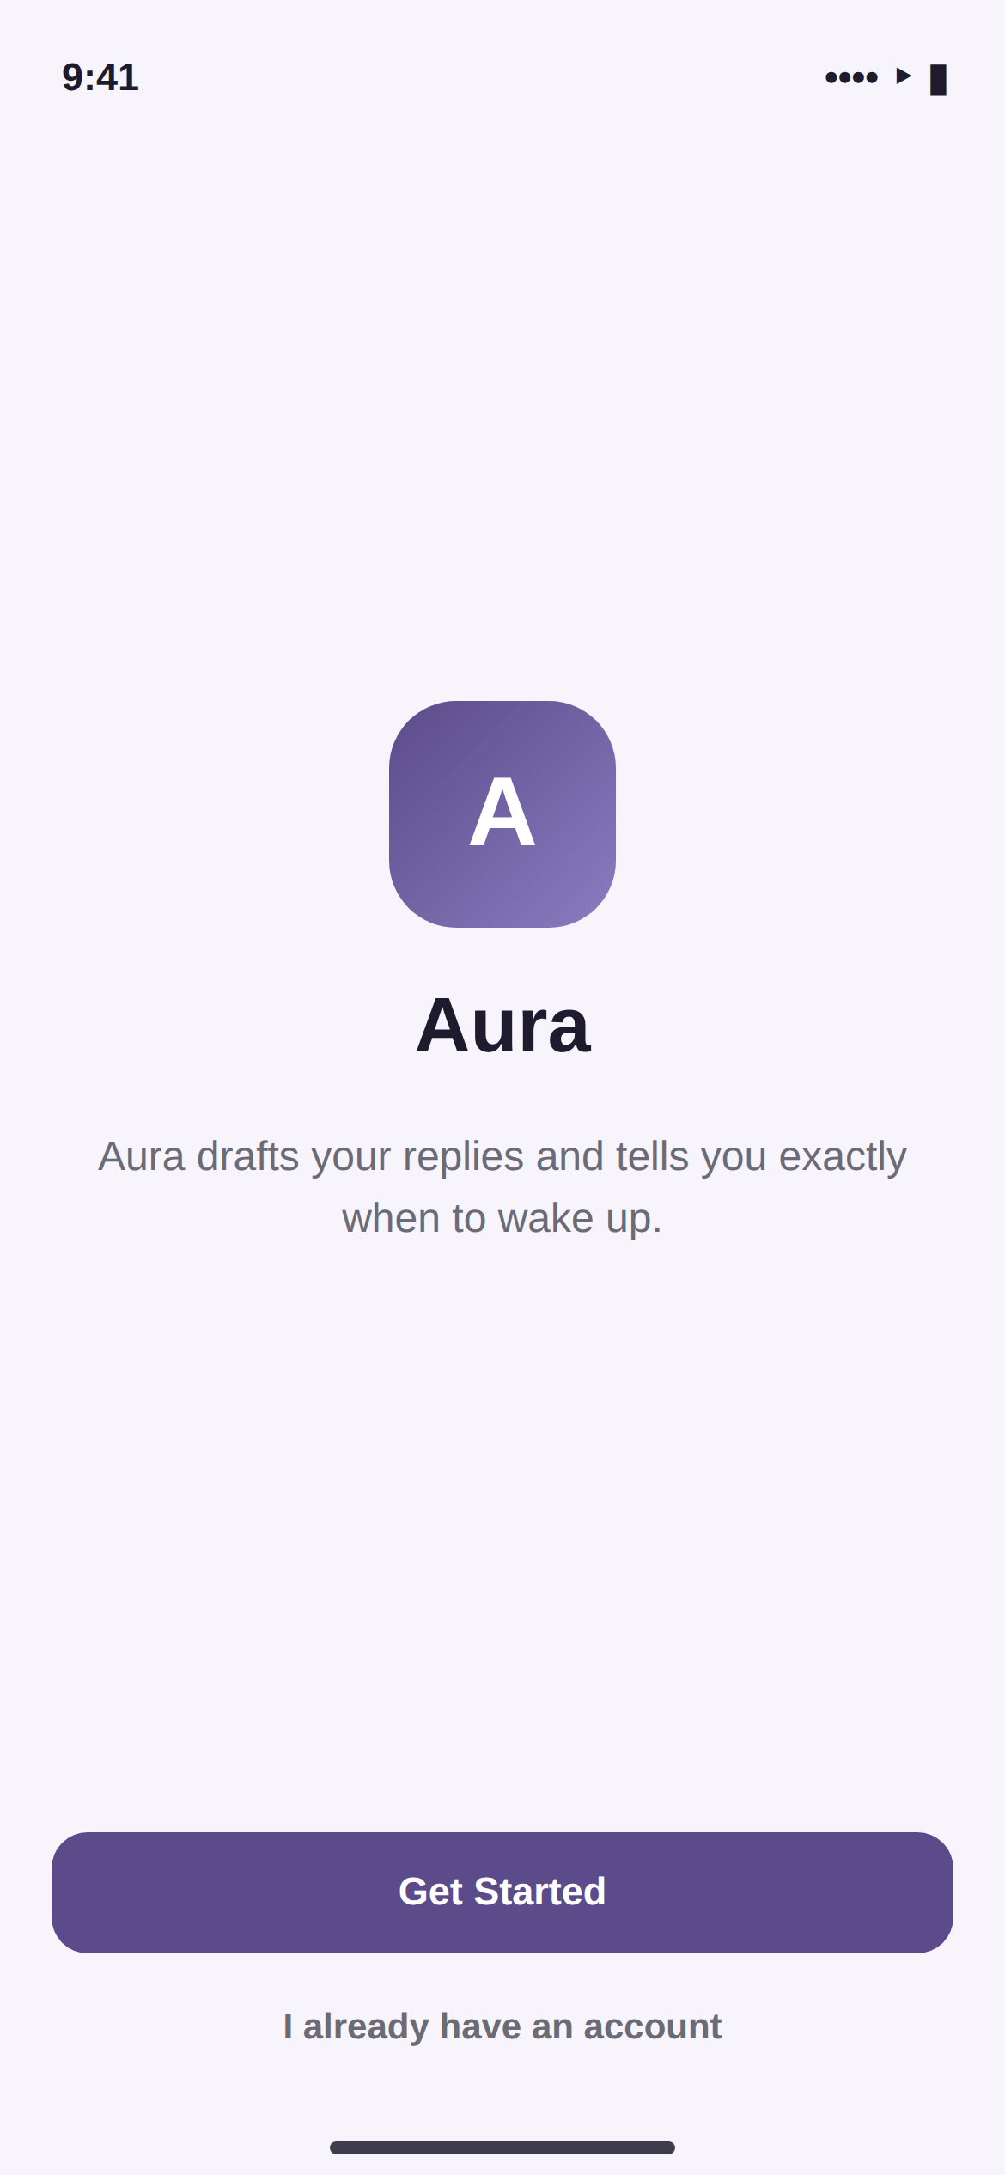 | Welcome screen  The very first screen a new user sees. One sentence explains the entire product; there is no feature carousel to skip past.  - Primary action: "Get Started" begins the connection flow.  - Secondary, low-emphasis text link for existing users to sign in instead.  - No account creation friction before this point — sign-up happens naturally as part of connecting the first account in step 4.2.

4.2 Connect Mail
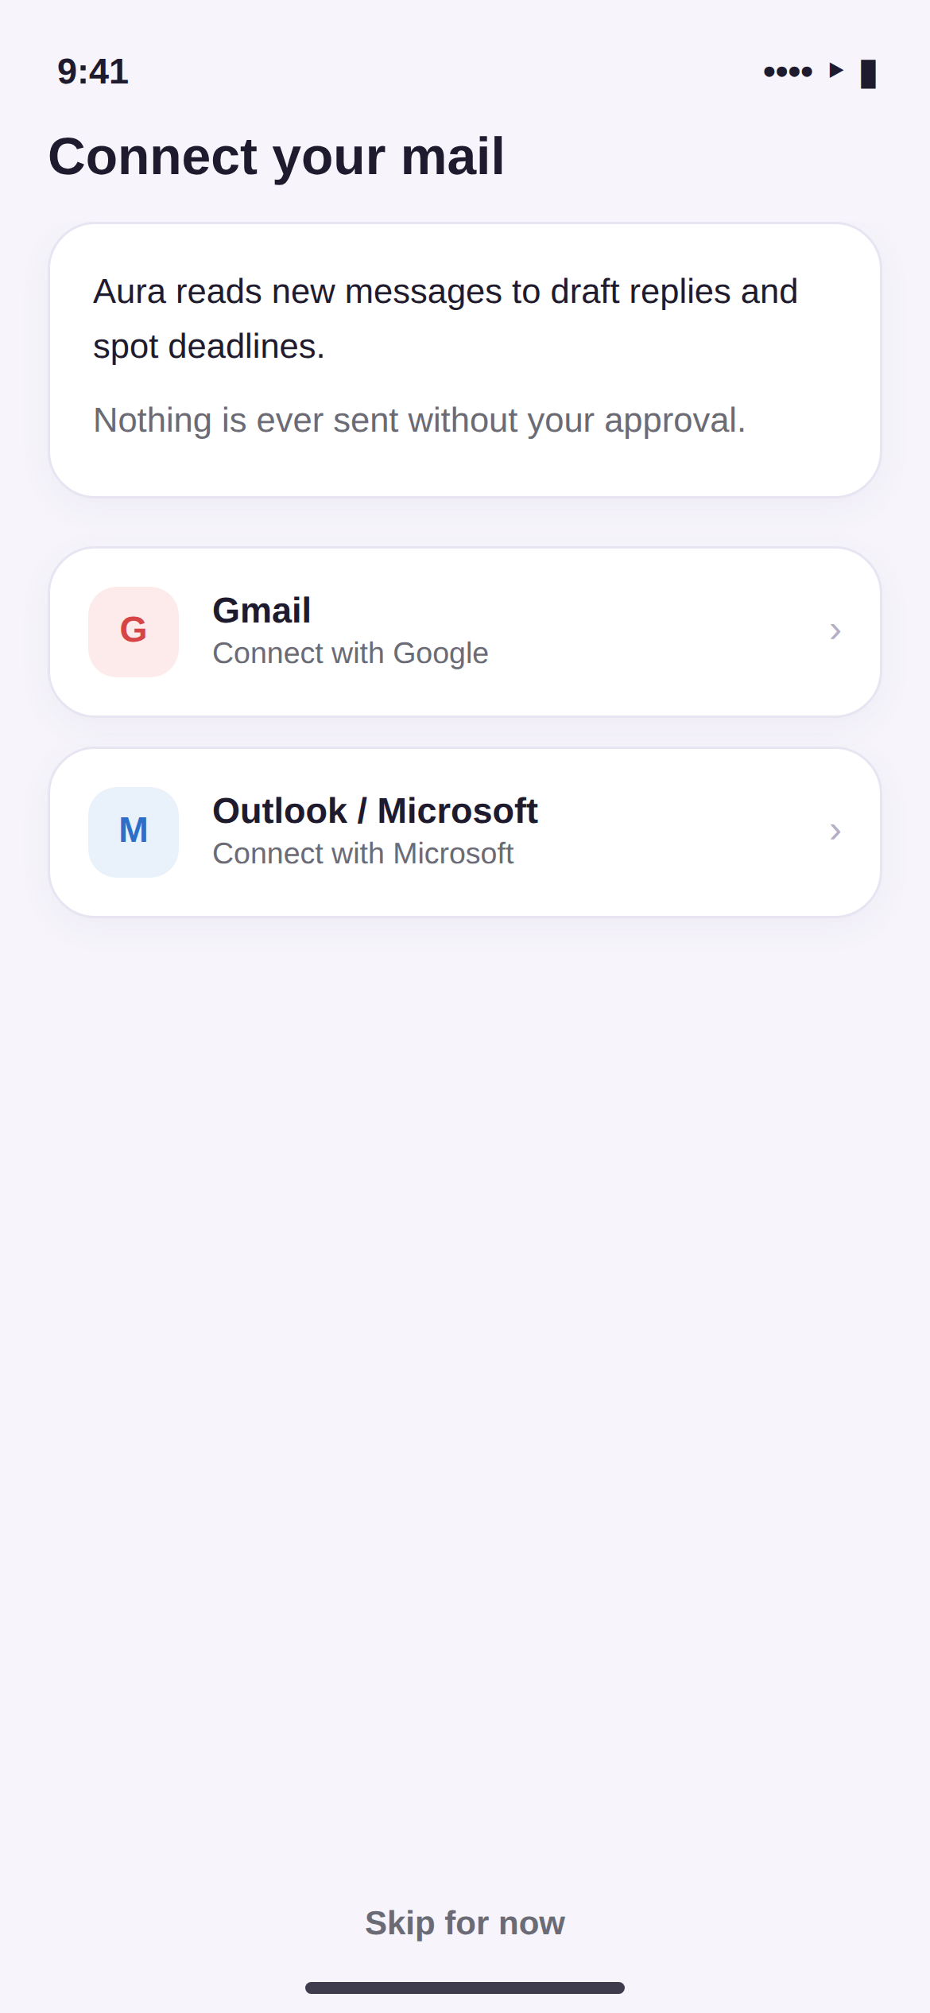 | Connect your mail  Before any system OAuth prompt appears, Aura explains in plain language what it will read and why — this explanation card is shown first, deliberately, rather than being left to the fine print.  - Two provider options at MVP launch: Gmail and Outlook/Microsoft.  - Tapping a provider opens the native OAuth sheet (ASWebAuthenticationSession) — Aura never asks for a password directly.  - "Skip for now" is available; a user can explore Aura's calendar/wake-time features without connecting mail immediately, though the full value only appears once mail is connected.

4.3 First Value
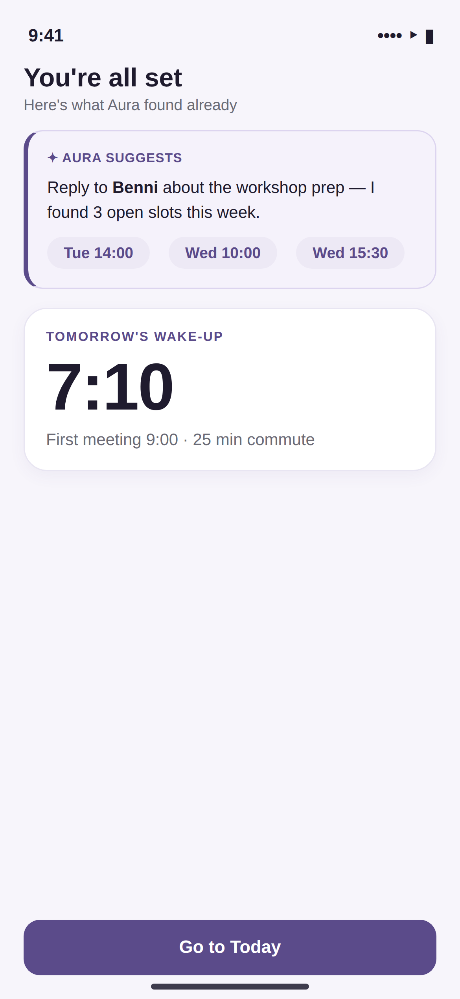 | You're all set  This is the most important screen in onboarding: it proves Aura's value inside the first 60–90 seconds, using the user's real data rather than a demo/sample state.  - Top card: a real drafted reply to an existing unanswered email, with real free time slots already computed from the connected calendar.  - Bottom card: tomorrow's actual computed wake-up time.  - One primary action — "Go to Today" — hands the user off into the main app shell.

5. The Today Screen (illustrated)
Today
The single screen a user should need to check once a day. Three stacked regions, top to bottom:
- Wake-Time Hero — tomorrow's computed wake-up time in large display type, with a one-line reason underneath. The pencil icon opens a one-day manual override without disabling the automatic system going forward.
- Today's Calendar Strip — a horizontally scrollable set of today's events pulled from every connected calendar, each showing time, title, and location.
- Needs Your Attention — a single merged queue combining drafted replies awaiting approval, to-dos with due dates, and calendar items needing confirmation. This list is deliberately unified rather than split into three separate lists, protecting the "one glance is enough" promise.
Badge color coding used throughout: neutral grey for routine review items, warm amber for approaching deadlines, and green for same-day/confirmed items — never red unless something is genuinely overdue, keeping the overall tone calm rather than alarming.

6. Inbox — Message List (illustrated)
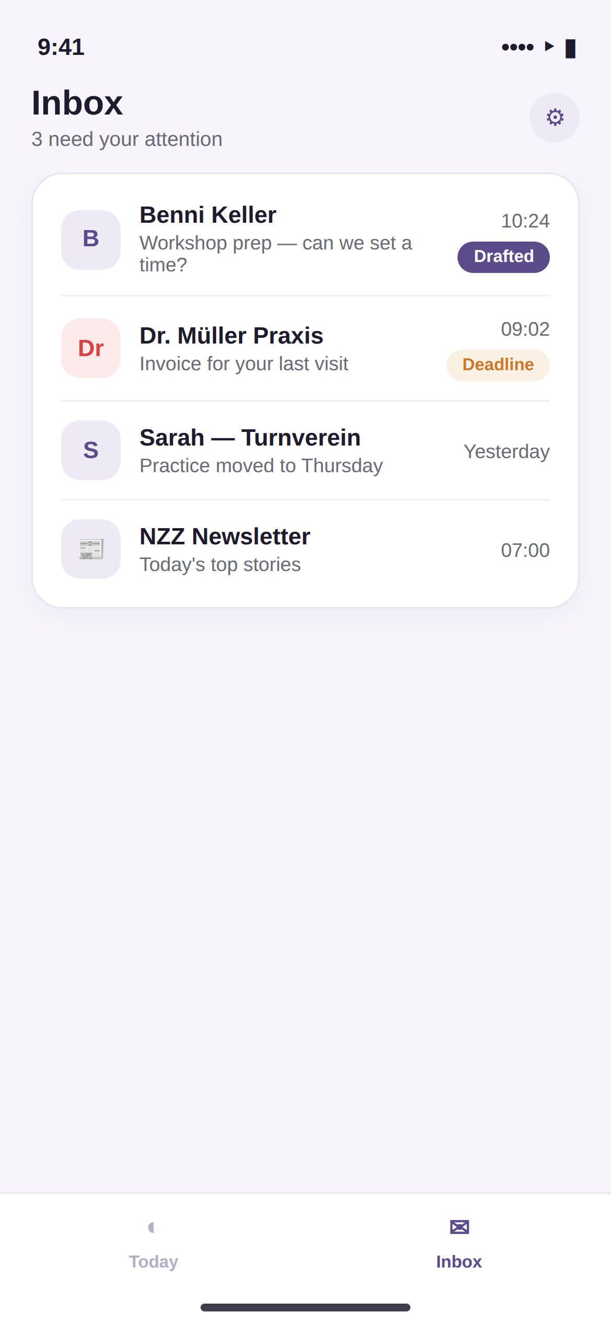 | Inbox  A familiar, standard-feeling inbox list — Aura does not reinvent email browsing, it augments it.  - A violet "Drafted" badge marks any thread where Aura has already prepared a reply, so the user can immediately spot what's ready for review.  - An amber "Deadline" badge marks messages where Aura detected a commitment or due date (e.g., an invoice, a request with a due date).  - Messages with neither badge are left exactly as a normal inbox would show them — Aura only adds signal where it has genuinely found something, avoiding badge fatigue.

7. Inbox — Reply Drafting (illustrated)
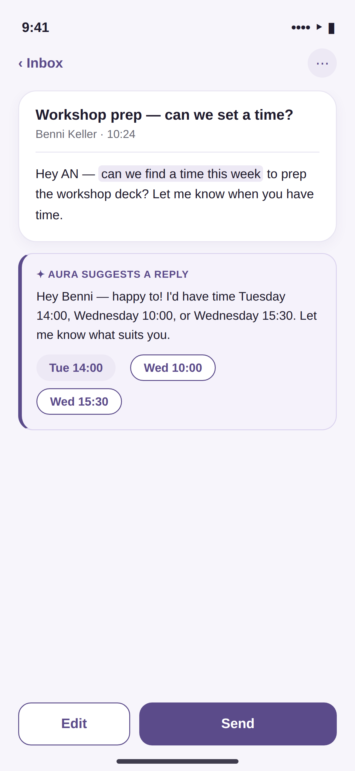 | Message + Aura's drafted reply  Opening a message shows the original content on top and Aura's proposed reply directly beneath it, always visually distinguished by the tinted, left-bordered "Aura suggests a reply" card.  - The sentence Aura used to detect a scheduling request is highlighted inline in the original message, so the user can see exactly what triggered the suggestion.  - Time Slot Chips show genuinely free calendar slots, already adjusted for travel-time buffers; tapping a chip updates which time is referenced in the draft.  - Two actions only: Edit (opens the draft as editable text) and Send (dispatches immediately as shown). There is no auto-send option in the MVP — every reply requires this explicit tap, by design.

8. Settings (illustrated)
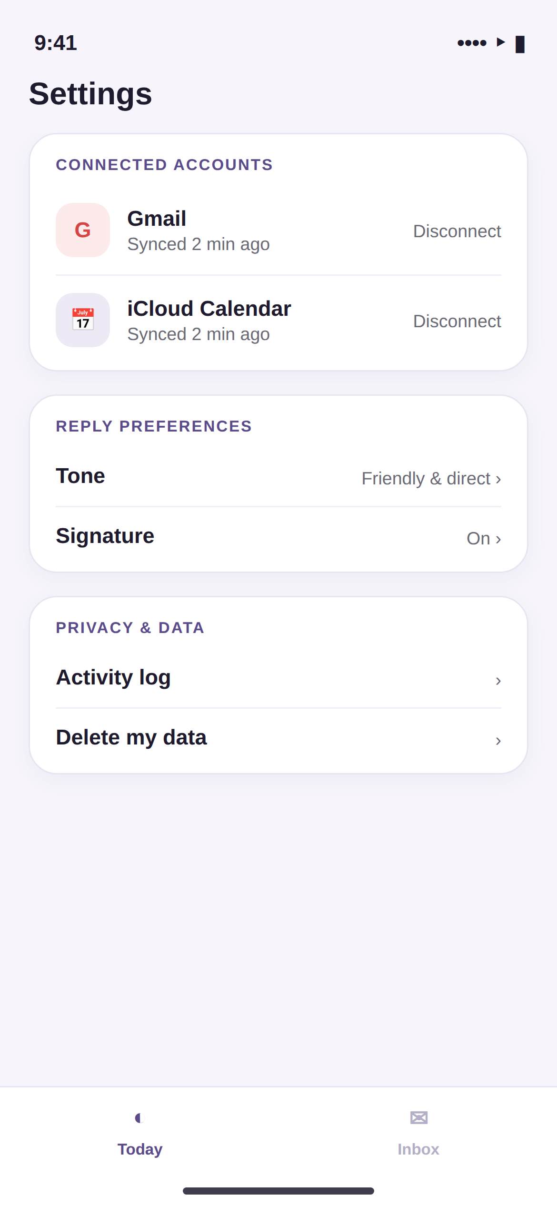 | Settings  Deliberately simple and infrequently visited. Three groups:  - Connected Accounts — shows each linked mail/calendar account with last-sync time and a one-tap Disconnect.  - Reply Preferences — tone and signature settings that shape how Aura drafts replies.  - Privacy & Data — a visible Activity Log (what Aura has read and drafted) and a direct "Delete my data" action, meeting the transparency commitment even at MVP scope.

9. Lock Screen Widget (illustrated)
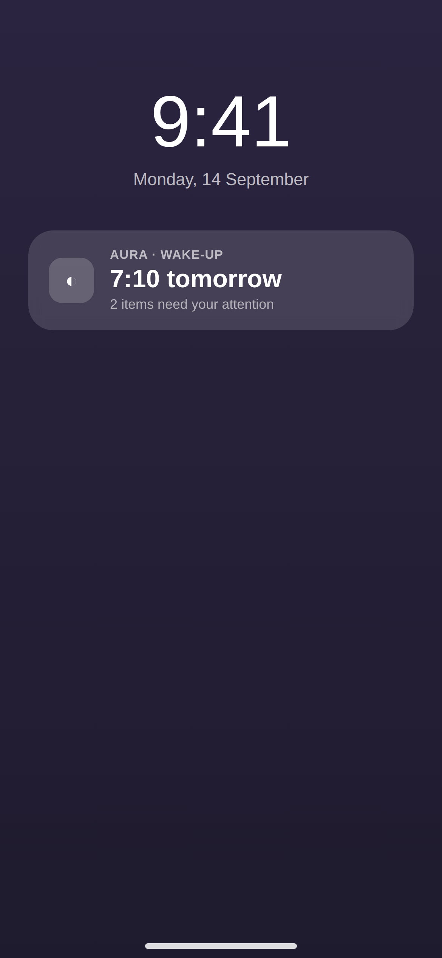 | Lock screen widget  Because Aura's value is meant to be felt before the app is even opened, the lock screen widget carries real weight in the experience — for many users, this may be the only "screen" they see most mornings.  - Always shows the next relevant wake-up time and a compact count of items needing attention.  - Tapping the widget deep-links directly into the Today screen.  - On the morning of a scheduled wake-up, this widget is replaced by a Live Activity showing a live countdown to the "leave by" time, updating automatically if traffic conditions change.

10. Full Journey Map: A Day With Aura
Time | What happens | Screen / surface
9:00 PM (the night before) | Aura recomputes tomorrow's wake-up time after the last calendar sync of the day and sends a quiet notification. | Push notification + Lock Screen widget
7:10 AM | User wakes up; opens the lock screen and sees the reason for the wake time without unlocking the phone. | Lock Screen widget
7:45 AM | Live Activity shows a live "leave by" countdown; traffic worsens slightly and the countdown adjusts automatically. | Live Activity / Dynamic Island
10:15 AM | A new email arrives asking to schedule a meeting; Aura drafts a reply with real open slots within seconds. | Push notification → Inbox / Reply screen
12:30 PM | User opens the Today screen once during lunch, sees the merged attention list, approves the drafted reply and confirms a to-do. | Today screen
6:00 PM | An invoice-like email arrives; Aura tags it with a deadline badge and silently adds a matching to-do. | Inbox (badge only, no interruption)
The intended experience is that most of this happens without the user consciously "using an app" at all — notifications and widgets carry the daily value, and the two in-app tabs exist for the moments a fuller review or edit is genuinely needed.

11. Interaction Rules Recap
- Every AI-generated piece of content is visually distinct (tinted card, violet border, "Aura suggests" label) — never presented as if the user wrote it.
- Every irreversible action (Send, in the MVP) requires one explicit tap — never a swipe, never an automatic timeout-based send.
- Badges use color deliberately and sparingly: grey for routine, amber for approaching deadlines, green for same-day/confirmed, red reserved only for genuinely overdue items.
- A manual override (e.g., wake-time) always applies to a single instance only and never silently disables the underlying automatic system.

12. Handoff Notes for Design & Engineering
- These mockups are functional wireframes intended to lock information architecture, hierarchy, and interaction — the visual design team should still produce final polish (custom iconography, refined illustration for empty states, exact SF Pro rendering) in Figma before implementation.
- All screens shown use placeholder sample content (names, times, messages); no real user data is depicted.
- Component boundaries in these mockups map directly to the Component Library defined in the Aura UI/UX & Build Documentation (Aura Suggestion Card, Time Slot Chip, Deadline Badge, Wake-Time Hero) — engineering should build each as a reusable SwiftUI view matching these exact visual states.
- Recommended next step: translate Sections 4–9 directly into a Figma file with real components and auto-layout, using this document as the content and hierarchy reference, before writing production SwiftUI code.

